What is a Component Diagram?

A component is a physical piece of implementation of a system, such as a module of software code. Components can be connected to other components through interfaces. A component diagram is a diagram that shows the organization and dependencies among component types.

Basic Component Diagram Symbols and Notations

Component

A component is a logical unit block of the system, a slightly higher abstraction than classes. It is represented as a rectangle with a smaller rectangle in the upper right corner with tabs or the word written above the name of the component to help distinguish it from a class.

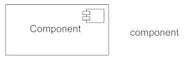

Interface

An interface (small circle or semi-circle on a stick) describes a group of operations used (required) or created (provided) by components. A full circle represents an interface created or provided by the component. A semi-circle represents a required interface, like a person's input.

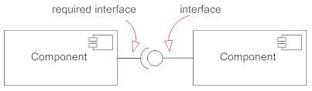

Dependencies

Draw dependencies among components using dashed arrows.

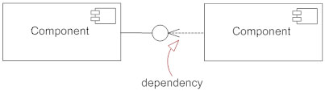

Port

Ports are represented using a square along the edge of the system or a component. A port is often used to help expose required and provided interfaces of a component.

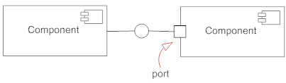

**example**

